What lessons are we learning from Coronavirus Lockdown?
Tim Yau, Transforming Norwich Minister’s Lunch 01-07-20

Praise Song for the Pandemic

Written and read by Christine Valters Paintner, from Abbey of the Arts and music by Giants & Pilgrims. https://youtu.be/zCYoikGaI6U

Praise be the nurses and doctors, every medical staff bent over flesh to offer care, for lives saved and lives lost, for showing up either way,

Praise for the farmers, tilling soil, planting seeds so food can grow, an act of hope if ever there was,

Praise be the janitors and garbage collectors, the grocery store clerks, and the truck drivers barreling through long quiet nights,

Blessings on our leaders, making hard choices for the common good, offering words of assurance.

Give thanks for bus drivers, delivery persons, postal workers, and all those keeping an eye on water, gas, and electricity,

Celebrate the scientists, working away to understand the thing that plagues us, to find an antidote, all the medicine makers, praise be the journalists keeping us informed,

Praise be the teachers, finding new ways to educate children from afar, and blessings on parents holding it together for them,

Blessed are the elderly and those with weakened immune systems, all those who worry for their health, praise for those who stay at home to protect them,

Blessed are the domestic violence victims, on lock down with abusers, the homeless and refugees,

Praise for the poets and artists, the singers and storytellers, all those who nourish with words and sound and color,

Blessed are the ministers and therapists of every kind, bringing words of comfort,

Blessed are the ones whose jobs are lost, who have no savings, who feel fear of the unknown gnawing,

Blessed are those in grief, especially who mourn alone, blessed are those who have passed into the Great Night,

Praise for police and firefighters, paramedics, and all who work to keep us safe, praise for all the workers and caregivers of every kind,

Praise for the sound of notifications, messages from friends reaching across the distance, give thanks for laughter and kindness,

Praise be our four-footed companions, with no forethought or anxiety, responding only in love,

Praise for the seas and rivers, forests and stones who teach us to endure,

Give thanks for your ancestors, for the wars and plagues they endured and survived, their resilience is in your bones, your blood,

Blessed is the water that flows over our hands and the soap that helps keep them clean, each time a baptism,

Praise every moment of stillness and silence, so new voices can be heard, praise the chance at slowness,

Praise be the birds who continue to sing the sky awake each day, praise for the primrose poking yellow petals from dark earth, blessed is the air clearing overhead so one day we can breathe deeply again.

And when this has passed may we say that love spread more quickly than any virus ever could, may we say this was not just an ending but also a place to begin.

The Lighthouse – A Parable

May 6, 2020 Paul Bradbury https://hislightmaterial.wordpress.com/2020/05/06/the-lighthouse-a-parable/
There was once a lighthouse that stood on a cliff above the shore. It was an important lighthouse warning ships away from danger. It had stood on the cliff for as long as anyone could remember. But the cliff was starting to erode and fall into the sea.
Each winter storms came and some of the cliff would be lost into the sea. And each year the storms got worse. And each year the edge of the cliff got closer to the lighthouse. So the people of the village got together and asked – what shall we do? Soon the lighthouse will fall into the sea and the lighthouse will be lost and ships will not be safe.
And some said – the lighthouse has always been here, it will be here for years to come. Don’t worry! And others said – we will move the lighthouse! Brick by brick back from the edge of the cliff. And others said– the lighthouse wasn’t built to last forever! If you move the lighthouse it will only last a few more years before you have to move it again!
But some posed a different question to the people: if we let the lighthouse fall into the sea, what other ways are there of doing its job of warning ships away from danger? They argued that the storms were here to stay, the weather was getting worse, the erosion of the cliff was going to continue because the climate was changing.
The argument raged on in the village. Some taking one position and others another. A group started with the aim of preserving the lighthouse in its present position. Another group started a fundraising campaign to move the lighthouse in from the edge of the cliff. And a small number began talking to the sailors and the fisherman asking them for creative solutions to the problem of how to know where the rocks are and how to warn ships to avoid them. And the storms came and the cliff continued to erode and the lighthouse continued to get closer to the edge of the cliff.
Where do you fit in this parable?

Fractured Nature
(John Lennox, 2020, Where is God in a Coronavirus World? [Kindle Locations 494-499]).
John Lennox states, ‘In a fractured world, damaged through the consequences of human sin, pain and suffering are inevitable. Perhaps we had hidden from this reality until coronavirus rampaged across the globe. Now we cannot ignore it, nor the big questions about life and death which it prompts. Here is C.S. Lewis again: “We can ignore even pleasure. But pain insists upon being attended to. God whispers to us in our pleasures, speaks in our conscience, but shouts in our pains: it is His megaphone to rouse a deaf world.” (Geoffrey Bles, 1940, The Problem of Pain, p.81)
What is God saying to us through the Coronavirus?

Bitter Providence
⁴ In everything we do, we show that we are true ministers of God. We patiently endure troubles and hardships and calamities of every kind… ¹⁰ Our hearts ache, but we always have joy. (2 Cor 6: 4, 10a New Living Translation)
“The secret of “sorrowful, yet always rejoicing” is this: knowing that the same sovereignty that could stop the coronavirus, yet doesn’t, is the very sovereignty that sustains the soul in it.” (John Piper, 2020, Coronavirus and Christ, p.22)
How will we model hope and not just give stock answers?
Disruption or interruption?
Many churches have innovated during this lockdown by embracing new technology and new patterns such as:
- Running meetings online
- Leading teams remotely
- New financial plans
- Redeploying staff for things they weren’t trained for
- Making church work in homes
- Creating new ways to serve communities
However, the progress we’ve made through innovation is at risk if we just see the lockdown as just an interruption and we expect things will go back to the way they were.
What if we see this as God’s disruption, a moment to assess not just what we’re doing and how we’re doing it, but why we’re doing it the first place?

Gospel Reading
Jesus speaking about his death to Andrew and Philip after the triumphant entry to Jerusalem.
“The time has come for the Son of Man to be glorified. I tell you the truth: unless a grain of wheat is planted in the ground and dies, it remains a solitary seed. But when it is planted, it produces in death a great harvest. The one who loves this life will lose it, and the one who despises it in this world will have life forevermore. Anyone who serves Me must follow My path; anyone who serves Me will want to be where I am, and he will be honoured by the Father.” (John 12:23-26 - VOICE)
If we believe in death and resurrection what are we willing to let die?
If our message stays the same which of our methodologies need to change?

New Normal
We’ve moved church online, but how do we become digital church natives? Not just online services but collaborative co-creative contextual communities?
One priest said to me, “We can’t go back to staring at the back of people’s head when we’ve become so used to meeting face-to-face on Zoom.”
We’ve moved church into homes, but how do we facilitate and nurture ‘oneness’ when we’re all separate? Why does someone need to come to church when they can access a multitude of religious services and communities around the world?
We’ve moved church into the community, but how do we make the most of the goodwill and new relationships we’re making in the process?
Another priest said to me, “The coronavirus has allowed the space to do the things in the community I’ve been longing to do since I took on the post.”
What is it that we want our paid key-workers to be used for?
What should they stop doing so that that they can do what they need to do in their local communities in the ‘new normal’?
Statistics
Only 9% of Britons want life to return to 'normal' once lockdown is over (https://news.sky.com/story/coronavirus-only-9-of-britons-want-life-to-return-to-normal-once-lockdown-is-over-11974459
24% of people say that they have accessed worship via the web or other media during lockdown, 5% of whom say they have never been to church. The proportion is 34% among 18-24s. This is significant. (www.tearfund.org/en/media/press_releases/many_brits_look_to_faith_during_lockdown/)
Many will have given thought to big, spiritual questions during this time.
How can the church get ready to engage and support lockdown spiritual seekers?

How To Create Real, Lasting Change After Covid-19
Ian Burbidge, 29th April 2020 www.thersa.org/discover/publications-and-articles/rsa-blogs/2020/04/change-covid19-response
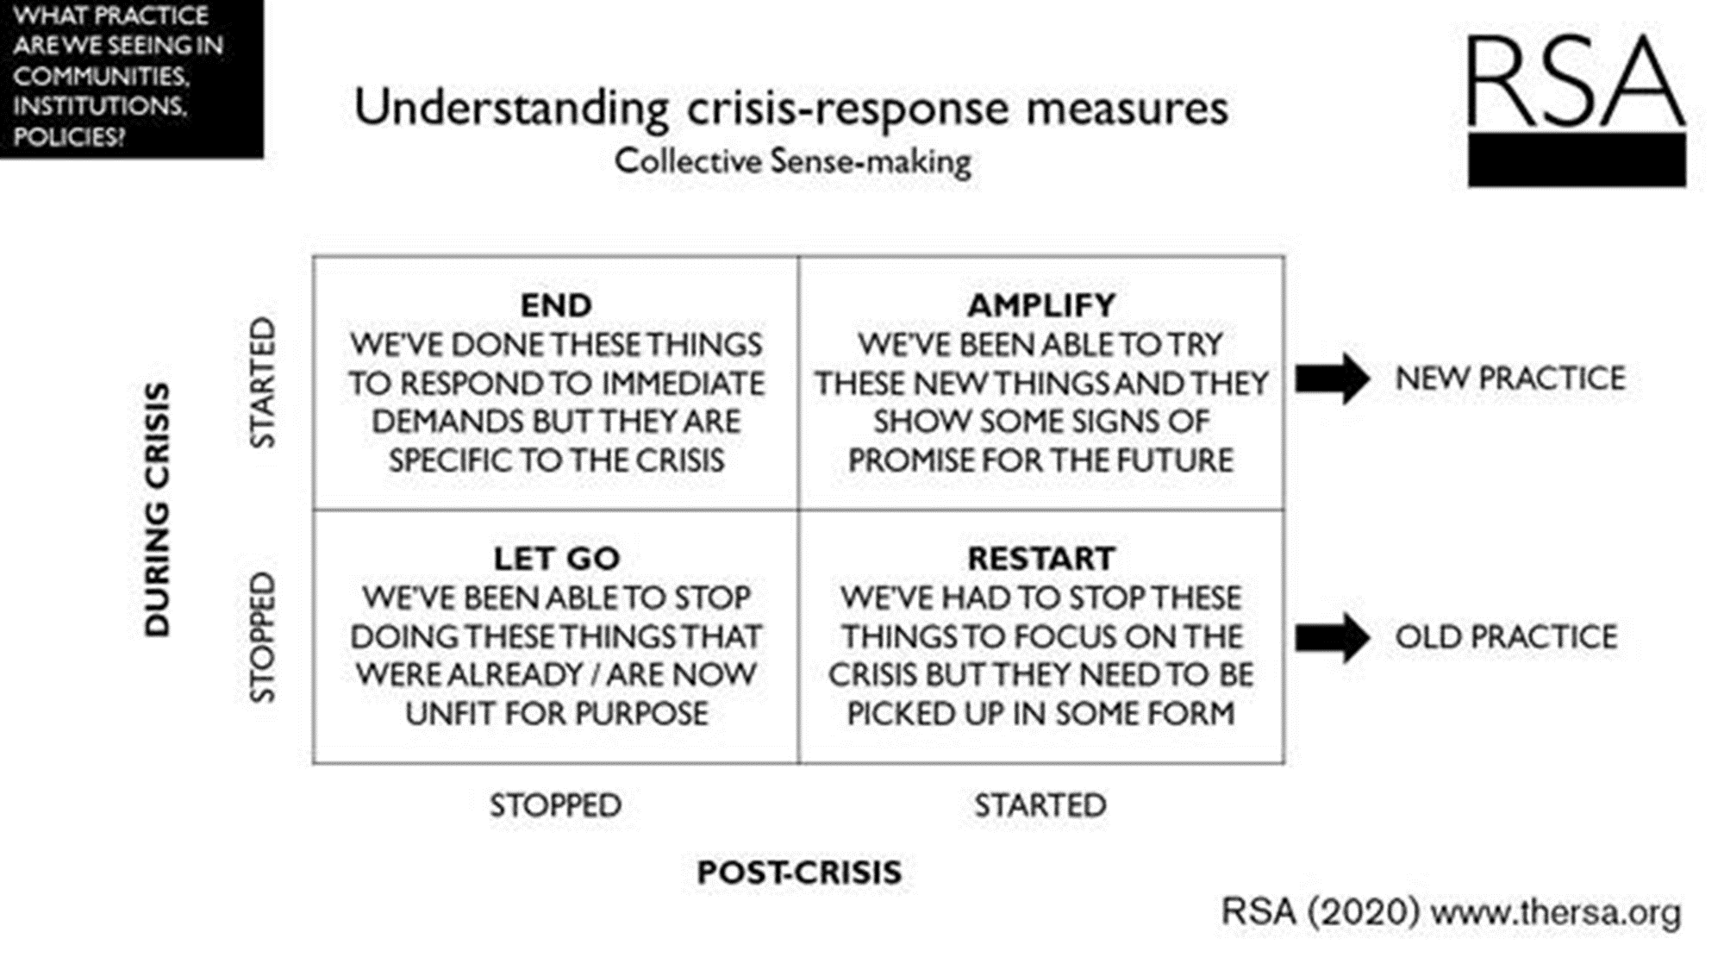
How could you use this grid for your mission and ministry post lockdown?
Future Church
“The church which comes out of lockdown will, I think, be digitally promising, physically smaller, more financially precarious and tentative, and potentially more flexible and interesting.”
(Rev. Rachel Mann, Anglican Priest, Poet and Theologian)
(http://therachelmannblogspot.blogspot.com/2020/05/where-do-we-go-from-here-towards.html)
What will your future church look like?

